Tutorial 3

In this tutorial we will be looking at shaders as an integral (and indispensable part of the programmable graphics pipeline). We are using the same example code as last week but looking at a different aspect of it.

At the most basic level there are two main components of modern graphics hardware which we are interested in and interact with directly to produce graphics: The Vertex Processor and the Fragment processor. There are other shader types and processors available but for the moment we will look at this simplistic model.

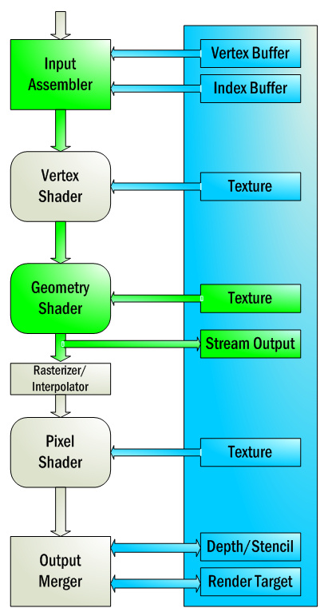

Here we have a representation of the graphics pipeline and we are concerned today with the VERTEX SHADER stage and the PIXEL SHADER (Also referred to as FRAGMENT SHADER) stage.

From last week you remember altering the arrays containing the data representing the triangle. These arrays are fed in at the beginning of the pipeline (as you can see in the diagram) and the data is manipulated by each stage of the pipeline to produce and end result. If we do not specify a vertex and pixel shader to process this data, NOTHING will be rendered at all!

The example has a very simple vertex and fragment shader. The vertex shader does the basic transformations (World, View, and perspective) and the fragment shader assigned a basic color to every pixel in the model but obviously things can be much more complex than this.

In this example the shaders are calculating the basic transforms and applying. This is still even a basic shader and as can be seen in modern games, truly spectacular results can be achieved and they are all done so through shaders.

We will look at shader management and more advanced techniques later on but the idea here is to understand the basic principles of the vertex and fragment shader.

The first such principle is that the shader is a PROGRAM in its own right that is executed on the hardware (either the vertex or pixel processor) therefor it must be compiled just as our own projects are.

Task: Look in the ColorShaderClass::InitializeShader method to see where the shader is loaded. The entire ColorShader class is associated with the management and use of the light shader and we will handle all our shaders in a similar manner.

When the shader is compiled the most important thing is error checking and control. Since it is compiled at this step there may be compilation errors! And it is important to catch these to alert the developer.
Enter some non-code text into the color.vs file to see the shader compiler throw an error.

As shaders get more and more complex debugging them becomes essential as you can see all we received there was a simple error, there was no information regarding what the error was or where. Without more information, debugging a complex shader can be an absolute nightmare.
Luckily there are tools available that provide this kind of functionality but are not needed at the moment.

It is important to note that the vertex shader will run once for every single vertex and the pixel shader will run once for every single pixel. You can imagine how many iterations this becomes rendering models with complex geometry or when we come to do more advanced techniques rendering models multiple times. This highlights the need for shader code to be both effective and highly efficient to make the most of the power available.

Task: now we are going to play with the vertex shader to manipulate the geometry of the triangle. Although the straight transformations will give us the triangle as described, it is possible to write shader code that will manipulate the geometry to give different effects.

Please note that the language used to write shaders may look like C++ and share a lot of the notation but it is actually a language called HLSL

Inside the shader we can manipulate the data in any way we want: For example before the
// Calculate the position of the vertex against the world, view, and projection matrices.
output.position = mul(input.position, worldMatrix);
output.position = mul(output.position, viewMatrix);
output.position = mul(output.position, projectionMatrix);

section add in this line

input.position.x = input.position.x *2;

This will multiply the x value of every vertex by 2 that passes through the shader. The net effect then is that the object is scaled.

Feel free to mess with the values here before moving on.

Its important to note how data is INPUT and output through the vertex shader to the pixel shader.

The section:
//////////////
// TYPEDEFS //
//////////////
struct VertexInputType
{
float4 position : POSITION;
float4 color : COLOR;
};

struct PixelInputType
{
float4 position : SV_POSITION;
float4 color : COLOR;
};

Describes the data types we are passing through. We get a VertexInput Type into the vertex shader (passed in) and it returns a PixelInputType which is passed onto the pixel shader.

As we use more and more data the complexity and specicivity of these input and output structures will increase but in the long run it should always be specific to the actual shader you are using rather than having redundant data which is not used.

TASK:

Altering the pixel shader.
At the moment the pixel shader is pretty simple. As you can see it takes in the position and the color and the output color is simple set as the color that comes in as the input data (Which is defined way back in the array.

IN the same way we altered the vertex shader consider how you could alter the pixel shader to VARY the color rendered with the position of the pixel! All the information is there, you just need to decide how to use input.color with the input.position to change the result.

